Agilitech Solutions introduces DocMD, the new solution for advanced, deep inspection document scanning for accessibility across all your organization’s websites. Deploy DocMD quickly and seamlessly – simply activate license, load URLs and start scanning.

* Supports and integrates with several remediation workflows
* Segmented and Customized Reporting
* Analyzes and displays trends and compliance progress
* UI is fully accessible to screen readers and other assistive technology
* Supports and validates all major document types: ISO 32000, Section 508, WCAG 2.0, WCAG 2.1, HHS, HHS 2018, PDF/UA 1.0, ADA, Microsoft and EPUB
* Competitively Priced
* Cloud-based, secure SaaS platform for document accessibility
* Deep Inspection Scanning
* Searches, validates and reports document compliance for all formats
* Drill-Down accessibility report for each document
* Facilitates and helps prioritize your remediation strategy
* Summarizes, charts, trends, presents at all levels of the organization
* Analyzes and reports at any or all organizational levels

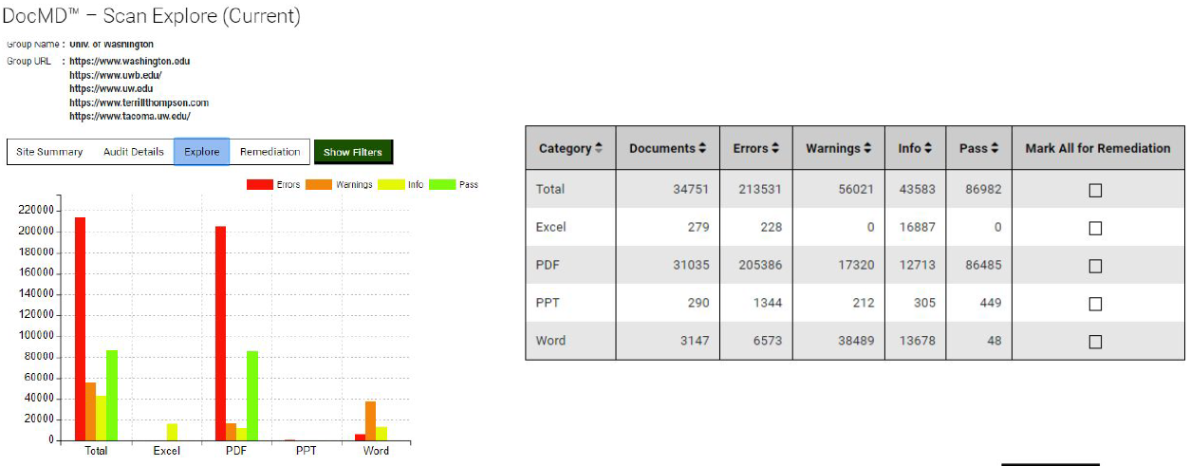A Screenshot showing enterprise scan including document types, numbers, errors and warnings in graphical and table (alternative accessible) formats. User can select checkbox to submit single or group of documents for remediation to the team of your choice – internal or external.

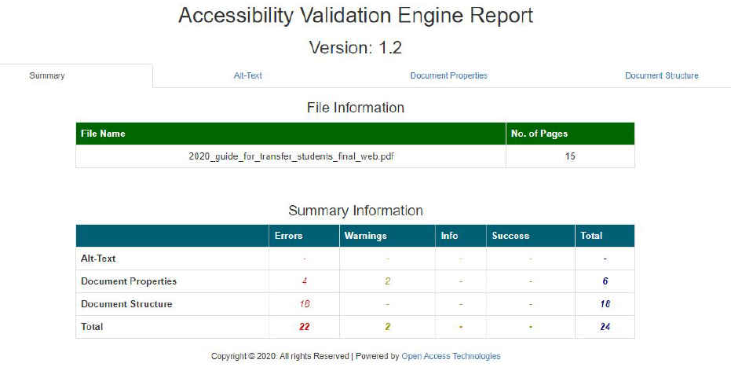Summary example of single document accessibility Validation Report showing alt text, document properties and document structure tabs and summary information

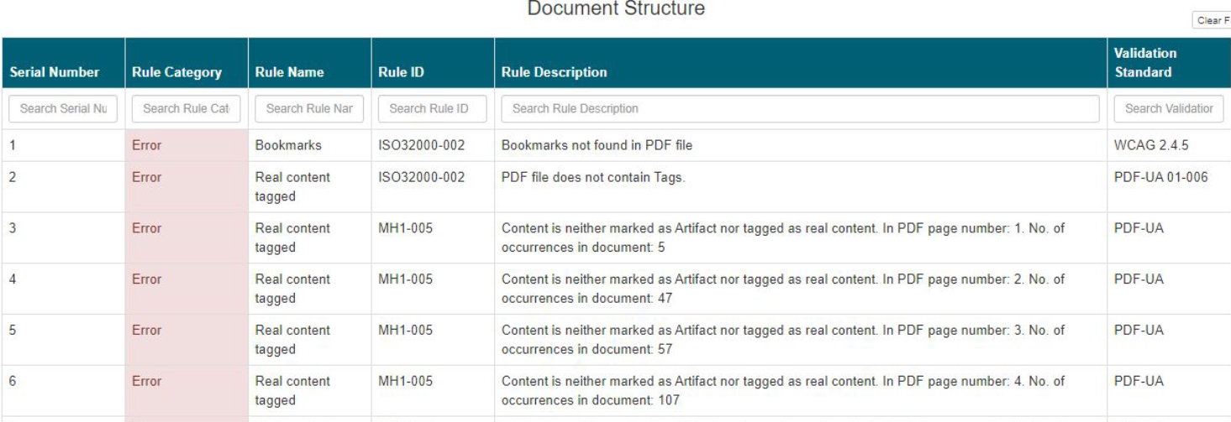Example Document structure report detail for a single document